**Laboratory 01: Installation, Git, and Hello World**

**Install Java**

1. Download and install **7-zip**:
   * [**7-zip**](http://www.7-zip.org/)
2. Optional: Download and install **Notepad++**:
   * [**Notepad++**](https://notepad-plus-plus.org/)
3. Download and install [**Sublime Text**](https://www.sublimetext.com/)
   * Sublime has a nice option to encode your class file as Hexadecimal, in order to view the Byte code (necessary for the final section of this lab)
4. Download and install [**Eclipse IDE 2019‑06 R**](https://www.eclipse.org/downloads/packages/) 64 bit for your Operating System
   * Choose Eclipse IDE for Java Developers
   * Leave the default installation paths
   * Choose install
5. Download and install the latest [**JDK**](https://www.oracle.com/technetwork/java/javase/downloads/jdk12-downloads-5295953.html) **(Java Development Kit)** for your Operating System:
   * Make sure to agree to the licensing agreement in order to download
   * To check that it is installed, open up your command prompt and type **java -version**
   * To check that the java compiler is installed, type **javac -version**
   * If you are having problems with java being recognized, do the following: (Windows only)
     + Make sure to use the version of java that you downloaded (C:\Program Files\Java\ jdk-12.0.2)
     + Go to **Advanced System Settings** (search “adv”)
     + Click on **Environment Variables**
     + Click **New** at the bottom under *System variables (not your User variables)*
       - insert the variable name as: **JAVA_HOME**
       - insert the variable value as the path to your JDK install: **C:\Program Files\Java\jdk-12.0.2**
       - Click **Okay**
     + Click on the System variable **Path** at the bottom under *System variables*, and then select edit
     + Click **New** and type: **%JAVA_HOME%\bin**
       - Click **OK**
     + Click **OK**
     + Check once again if java & javac are installed by opening a **new** command prompt
       - If you are still having an issue, you may need to restart your computer and check for java and javac once more
   * If you are having problems with java being recognized and you use linux, try the following commands:

SET PATH="C:\Program Files\Java\jdk-12.0.2\bin";%PATH%

export PATH=”/usr/bin/java:$PATH”

* + - note: /usr/bin/java is just where java is on your machine

1. Open your favorite text editor and write the following code:

**public** **class** HelloWorld {

**public** **static** **void** main(String[] args) {

System.***out***.println("Hello World");

}

}

1. Save the file as HelloWorld.java
   * **Note: In Java, your file name must be the same as your class name**
2. Open a command line in same directory as HelloWorld.java and type: **javac HelloWorld.java** //this compiles your .java program into a .class file (Byte code that can be interpreted by JVM)
3. To run the file, type **java HelloWorld** //this runs your program
4. Now you will run HelloWorld with a batch file (Windows Only)
5. Create a new file called make.bat
6. Open up make.bat in a text editor, and add the following code: (rem is a comment in batch files)

@echo off rem silently turns off command echoing

cls rem clears the command prompt

javac HelloWorld.java rem to compile

java HelloWorld to run

1. Note that javac *.java will compile all java files within the working directory
2. To run, within the same directory as both make.bat and your HelloWorld program, simply type make at the command prompt
3. Now you will run HelloWorld in the Eclipse IDE
4. Open up Eclipse and select the directory you would like to make your workspace (I left the default location for my installation)
5. Choose **File>New>Java Project** and name the project **Hello World**
6. When asked to create a module name select **Don’t Create**
7. In Package Explorer, under the src directory select **File>New>File,** name the file **HelloWorld.java**, and type in your HelloWorld Program
8. Save the file, then select **Run>Run** or click  to run your program in Eclipse

**Install Git (Provides a convenient way to work with partners)**

* Navigate to [**http://git-scm.com/downloads**](http://git-scm.com/downloads) and download Git for your operating system.
* Double click your downloaded file.
* Click Next.
* Uncheck Git HUI Here and click Next.

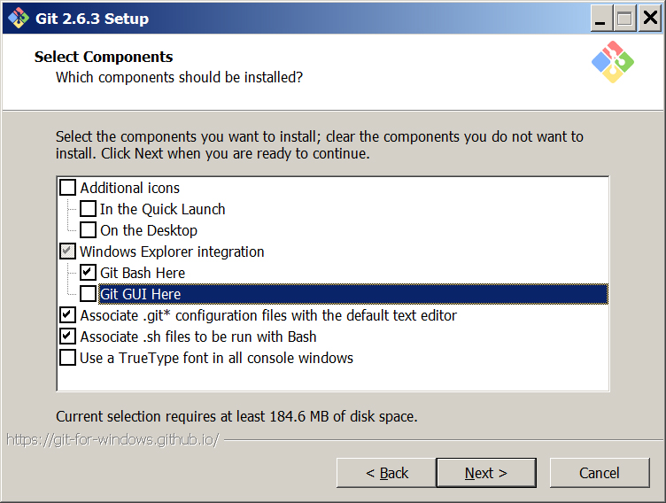

* Choose your default editor for Git and click Next.
* Configure as shown below and click Next.

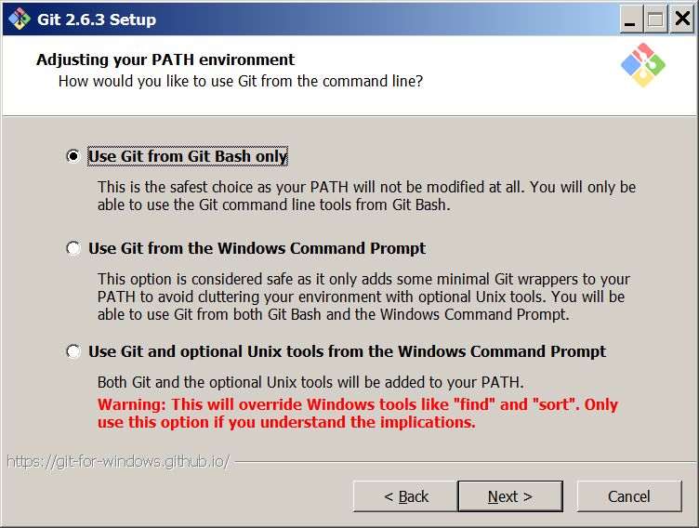

* Select Use OpenSSH and click Next
* Select Use the OpenSSL library and click Next
* Configure as shown below and click Next.

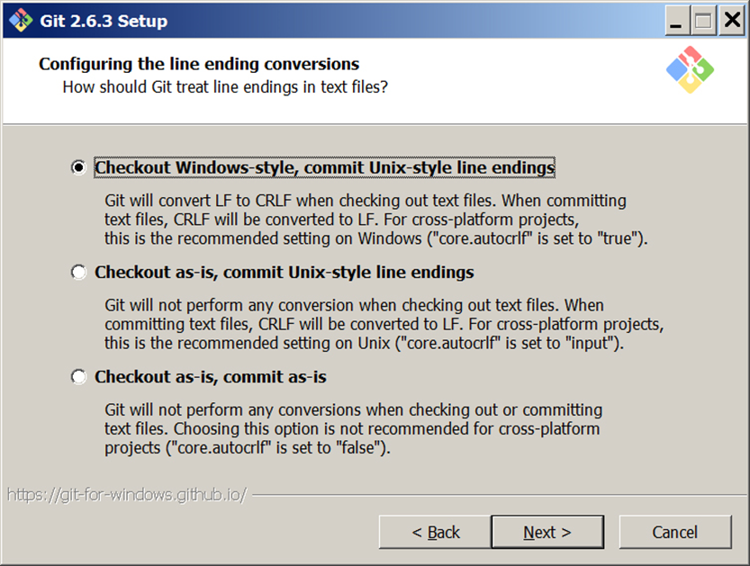

* Configure as shown below and click Next.

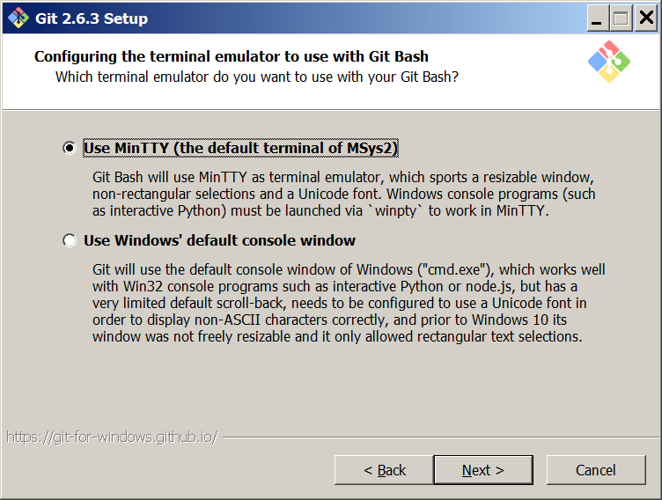

* Leave Enable file system caching unchecked and click Next.
* Wait for the install to finish and click Finish.

**Submit a short program to ilearn that simply prints out your name, your partner’s name (if you have one), and your lab section.**

**If you get finished with this part, feel free to move onto the Java Byte Code portion. There is no deliverable for this part, however, it is very interesting!**